ANOVA Analysis of Supply Chain Efficiency and Product Quality
STAT 301 Group Project | n = 100 Observations

Introduction

Dataset
This project analyzes a supply chain dataset containing 100 observations and 24 variables. The dataset documents operational and quality metrics across a consumer goods supply chain in India, covering product categories, supplier performance, shipping logistics, manufacturing output, and defect outcomes. The dataset was obtained from a publicly available Kaggle supply chain repository and was cleaned prior to analysis.

Research Questions
Two research questions are examined using ANOVA:
- Question 1 (One-Way ANOVA): Does product type significantly affect manufacturing costs?
- Question 2 (Two-Way ANOVA): Do transportation mode and product type interact to affect defect rates?

Variables
The following variables are used in this analysis:
- Product Type — categorical variable with 3 levels: cosmetics (n=26), haircare (n=34), and skincare (n=40). Identifies the product category of each SKU.
- Manufacturing Costs — continuous numeric variable representing total production cost in dollars per SKU. This is the response variable for Question 1.
- Transportation Mode — categorical variable with 4 levels: Air, Rail, Road, and Sea. Identifies the shipping method used for each SKU.
- Defect Rates — continuous numeric variable representing the proportion of defective units per SKU. This is the response variable for Question 2.

Hypotheses
Question 1 — One-Way ANOVA:
- H₀: Mean manufacturing costs are equal across all three product types (μ₁ = μ₂ = μ₃).
- H₁: At least one product type has a significantly different mean manufacturing cost.

Question 2 — Two-Way ANOVA (three sets of hypotheses):
- H₀ (Transportation Mode main effect): Mean defect rates are equal across all transportation modes.
- H₁ (Transportation Mode main effect): At least one transportation mode has a different mean defect rate.
- H₀ (Product Type main effect): Mean defect rates are equal across all product types.
- H₁ (Product Type main effect): At least one product type has a different mean defect rate.
- H₀ (Interaction): There is no interaction between transportation mode and product type on defect rates.
- H₁ (Interaction): The effect of transportation mode on defect rates depends on product type.

Methods

Data Cleaning and Processing
The dataset was imported into R. Two ambiguous column names were renamed for clarity: the supplier-side lead time column was renamed Supplier_Lead_Time and the order-side lead time was renamed Order_Lead_Time. No missing values were found in any variable. No duplicate rows were identified. All categorical variables were converted to R factors. An IQR-based outlier scan found no extreme values in the variables of interest. All 100 observations were retained for analysis.

Choice of Analysis
Question 1 uses a one-way ANOVA because there is one categorical independent variable (Product Type, 3 levels) and one continuous dependent variable (Manufacturing Costs), and the goal is to compare means across more than two groups. ANOVA is the appropriate extension of a two-sample t-test for three or more groups. Although the design is unbalanced (group sizes differ: 26, 34, 40), one-way ANOVA is robust to moderate imbalance. Tukey HSD post-hoc tests were planned to identify which pairs differ if the omnibus F-test is significant.

Question 2 uses a two-way ANOVA with interaction because there are two categorical independent variables (Transportation Mode and Product Type) and one continuous dependent variable (Defect Rates), and the research question specifically asks whether the two factors jointly influence the outcome. The dataset is unbalanced across the 4×3 = 12 cells (see Table 1), with cell counts ranging from 4 to 13. For unbalanced designs, Type I sums of squares (used by the default aov() function in R) produce results that depend on the order variables are entered, which is incorrect. Therefore, Type II sums of squares were used via the Anova() function from the car package, which tests each effect after controlling for all other effects and is order-independent. This is the standard and appropriate method for unbalanced two-way ANOVA. Assumptions of normality and homogeneity of variance were verified using the Shapiro-Wilk test and Levene's test respectively.

Results

Question 1: One-Way ANOVA — Manufacturing Costs by Product Type
Assumption checks confirmed the model is valid. The Shapiro-Wilk test on residuals showed no significant departure from normality (p = 0.112). Levene’s test confirmed equal variances across product types (p = 0.384). Both assumptions were satisfied. The ANOVA table is presented in Table 2 and the distribution of manufacturing costs across product types is shown in Figure 1.

Table 2: One-Way ANOVA Results — Manufacturing Costs by Product Type
Source | df | Sum Sq | Mean Sq | F value | p-value
Product Type | 2 | 629.0 | 314.6 | 0.370 | 0.692
Residuals | 97 | 82531.0 | 850.8 | — | —
Note: Significance level α = 0.05. ns = not significant.

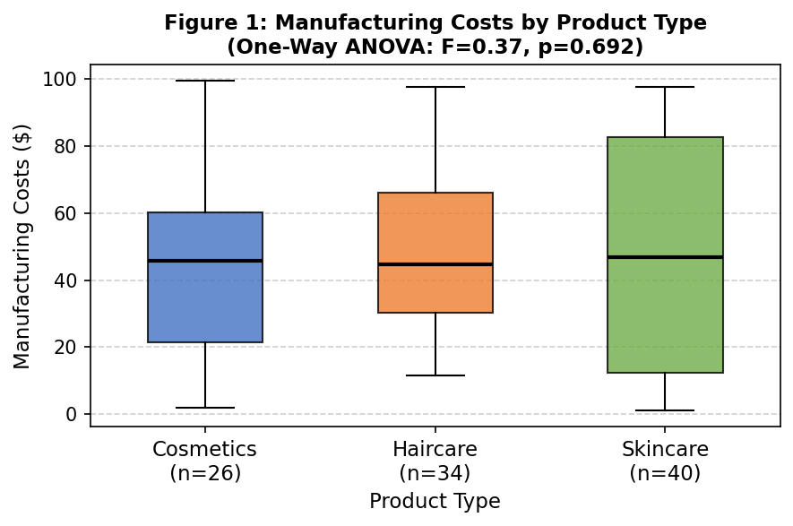
Figure 1: Boxplot of Manufacturing Costs by Product Type. Overlapping distributions and similar medians across cosmetics, haircare, and skincare are consistent with a non-significant result.

Question 2: Two-Way ANOVA — Defect Rates by Transportation Mode and Product Type
Table 1 shows the unbalanced cell counts across the 4×3 design, confirming that Type II sums of squares are required. Assumption checks showed no significant departure from normality (Shapiro-Wilk p = 0.068) and equal variances (Levene’s test p = 0.340). The Q-Q plot in Figure 2 provides visual confirmation that residuals follow the expected normal distribution. The full Type II ANOVA table is presented in Table 3, and the interaction is visualized in Figure 3.

Table 1: Cell Counts — Transportation Mode × Product Type (Unbalanced Design)
Transport Mode | Cosmetics | Haircare | Skincare | Total
Air | 5 | 8 | 13 | 26
Rail | 9 | 10 | 9 | 28
Road | 6 | 12 | 11 | 29
Sea | 6 | 4 | 7 | 17
Total | 26 | 34 | 40 | 100
Note: Cell sizes range from 4 to 13, confirming an unbalanced structure requiring Type II SS.

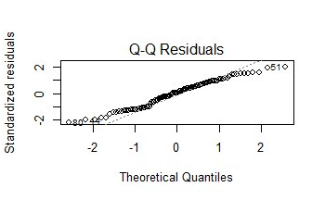
Figure 2: Q-Q Plot of Model Residuals (Question 2). Points follow the diagonal reference line closely, confirming the normality assumption is satisfied.

Table 3: Two-Way ANOVA Results (Type II SS) — Defect Rates by Transportation Mode and Product Type
Source | df | Sum Sq | F value | p-value | Significance
Transportation Mode | 3 | 7.68 | 1.35 | 0.263 | ns
Product Type | 2 | 2.37 | 0.62 | 0.539 | ns
Mode × Type (Interaction) | 6 | 21.99 | 3.05 | 0.014 | * (sig.)
Residuals | 88 | 105.22 | — | — | —
Note: ns = not significant; * = significant at α = 0.05.

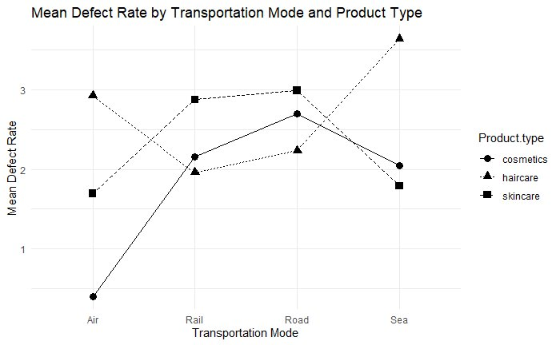
Figure 3: Interaction Plot — Mean Defect Rate by Transportation Mode and Product Type. The sharp divergence between cosmetics (circles) and haircare (triangles) under Air transportation confirms the significant interaction. Lines are roughly parallel under Rail, Road, and Sea, indicating no interaction in those modes.

Conclusion

Test Statistics and Decisions
For Question 1, the one-way ANOVA produced F(2, 97) = 0.370 with p = 0.692. Since p = 0.692 > 0.05, we fail to reject the null hypothesis. There is no statistically significant difference in mean manufacturing costs across product types. Tukey HSD post-hoc comparisons confirmed no significant pairwise differences: haircare vs. cosmetics (adjusted p = 0.757), skincare vs. cosmetics (adjusted p = 0.699), and skincare vs. haircare (adjusted p = 0.997).

For Question 2, the Type II two-way ANOVA produced the following results. The main effect of Transportation Mode was not significant: F(3, 88) = 1.35, p = 0.263. We fail to reject the null hypothesis for this main effect. The main effect of Product Type was also not significant: F(2, 88) = 0.62, p = 0.539. We fail to reject the null hypothesis for this main effect. However, the interaction between Transportation Mode and Product Type was statistically significant: F(6, 88) = 3.05, p = 0.014. We reject the null hypothesis for the interaction. Because the interaction is significant, the main effects cannot be interpreted independently.

Interpretation in Context
For Question 1, the finding means that within this supply chain, the cost of manufacturing a product does not meaningfully differ based on whether it is a cosmetic, haircare, or skincare product. All three product categories incur similar average production costs (cosmetics: $43.05, haircare: $48.46, skincare: $48.99), suggesting that manufacturing expenses in this supply chain are driven by other factors not captured in this analysis.

For Question 2, the significant interaction means that defect rates depend on the specific combination of transportation mode and product type, not on either factor alone. Post-hoc Tukey comparisons within each transportation mode revealed that the interaction is driven primarily by air transportation: cosmetics have significantly lower defect rates than haircare when shipped by air (estimate = −2.53, adjusted p = 0.005). No significant product-type differences were found under rail or road transportation. Under sea transportation, the comparison between haircare and skincare approached but did not reach significance (p = 0.085). The interaction pattern is clearly visible in Figure 3, where the cosmetics line begins near zero under Air while the haircare line starts near 3.0, before the lines converge under other modes.

Most Interesting Finding
The most interesting finding is the significant interaction in Question 2 and the contrast it creates with Question 1. Product type alone does not affect manufacturing costs (Q1), and transportation mode alone does not affect defect rates (Q2) — yet when transportation mode and product type are considered together, a meaningful quality difference emerges. Specifically, haircare products are significantly more prone to defects than cosmetics exclusively under air transportation. This reveals that the risk is not inherent to haircare products in general, nor to air transport in general, but arises from their specific combination. From a supply chain management perspective, this finding suggests that shipping decisions should be tailored to product type, and that blanket logistics policies may conceal important quality risks.

Limitations
- Sample size: With n = 100 observations distributed across 12 cells, some cells contain as few as 4 observations, which reduces statistical power and increases uncertainty in cell-level estimates.
- Observational data: The dataset is observational, not experimental. Causality cannot be established. Unmeasured confounding variables — such as shipping distance, packaging quality, or temperature sensitivity — may explain the observed interaction.
- Generalizability: The dataset reflects one supply chain context across five Indian cities. Results may not transfer to other industries, regions, or supply chain structures.

